Brett Stelly

Rendering Geometry

**Ability to render a cube with predefined vertex information.**

To render a cube with predefined vertex information, I created a function that creates the vertices and indices and passes the information into the MeshRenderer class’s initialize function.

A cube is made up of six different planes so, first, I create the vertices. I created a vector of type Vertex and called it vertices. I initialize vertices on declaration. I will need to create fourteen different instances of Vertex. The first four vertices will be the plane’s front face. I will need to create two more vertices for every other side. I only need two vertices for the other sides, because the indices will connect the two vertices to two other vertices that already exist on the plane’s front face to create another side of the plane. 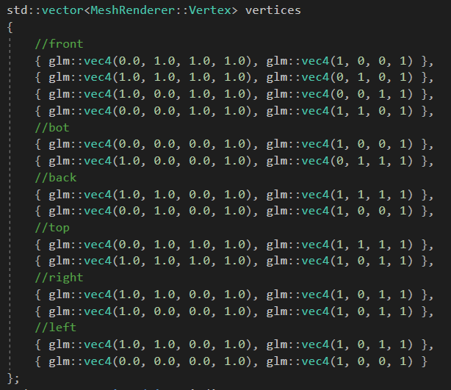

Once I finish creating the vertices, I then create the indices. Since a cube is different from a sphere and only requires a set number of points, I can manually put the indices in order that they should be connected. To do this I create a vector of unsigned int and then initialize it with the order to connect the points.

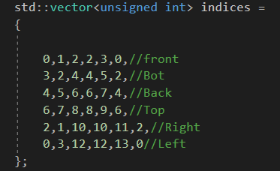

Finally I call the MeshRenderer class’s initialize function and pass in the vertices and indices variables.

**Finished Code**

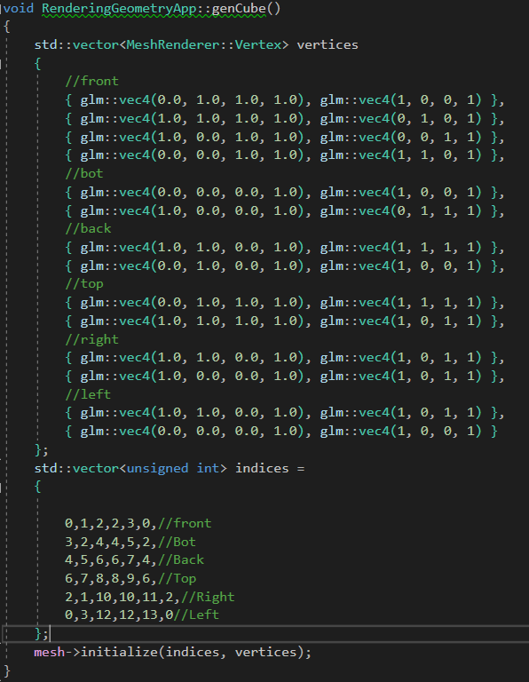

Rendered Cube

